Dear Members and Friends of HTLC,
Just a reminder that there is still time to send in your information to Pat. Normally we receive a pretty good response but with no worship services on Sunday, when most folks turn this in, not many requests have been returned this year.
In Christ,
Pastor Fischer

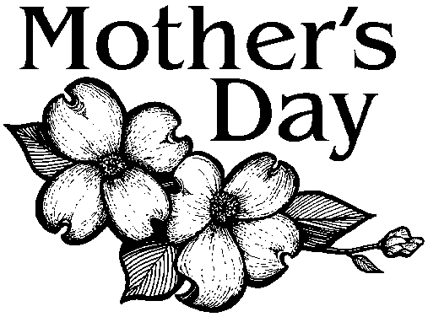
MOTHER’S DAY is Sunday, May 10th. A special offering, sponsored by WELCA, is being received and then given to deserving female students at the Lutheran Theological Southern Seminary. If you would like to make a donation In Memory Of or In Honor Of your mother, please fill out the form below and mail, or call the church office with your information. The names will be listed in Sunday’s bulletin and June’s Messenger. The deadline to do this is Thursday at 12:00 noon of this week.

In Memory of______________________________________________________________

Honor of_________________________________________________________________

Other (To the Glory of God)_________________________________________________

Given by___________________________________________________________________

